聘僱外國特定專業人才工作許可申請書(FSP-外國特定專業人才從事藝術及演藝工作專用)
Foreign Special Professional Personnel Employment Work Permit Application
單位章
單位（雇主）名稱： 單位印章：
Entity（Employer）Name Entity Seal
案件資訊 Application Information
工作類別  Category | F.藝術及演藝工作  Artistic and show business work |  |  |  | 申請項目  Application Type |  |  | （單選 Choose One）  □ 新聘New Hire  □ 展延Extension  原許可文號permit No._____  □ 補件Supplement  □ 提前解聘Early Dismissal  原許可文號permit No._____  □ 補發Re-issue  許可文號 permit No.______  □ 其他Other：____________
工作項目  Job Item | □ 02藝術工作Artistic work  □ 03大眾傳播之演藝工作Show Business  □ 04公開表演之演藝工作Performing Arts
□ 本案若係以團體形式在臺從事藝術或演藝工作，請勾選並填寫團體名稱：
Please check and fill the group name if foreign professional will work as group.
繳費資訊  Application fee |  | 繳費日  Payment date |  | 年 月 日  （Y） （M） （D） |  |  |  |  | 郵局局號  Branch code
劃撥收據號碼(8碼)或交易序號(9碼)
Receipt No.(8 digits) or transaction No.(9 digits)
本申請案回函  投遞地址 Application  Return Address |  | □□□ | 縣(County)  市(City) |  |  | 鄉鎮(Town)/市(City)  區(District)
路(Rd.) 段(Sec.) 巷(Lane) 弄(Alley) 號(No.) 樓(F.)
街(St.)

□ 本申請案若係委託私立就業服務機構辦理，請勾選，並填寫以下欄位資料。
Please check if this application has been entrusted to a private employment services agency and please fill out the following information.
1.受委託私立就業服務機構名稱：  Name of commissioned private employment services agency  2.許可證字號License No.：  3.專業人員Specialist：  （須親自簽名must sign personally）  4.聯絡電話Contact Tel： | （單位圖記Chop）  單位章  負責人章

□ 本申請案回函欲親自取件者請打「ˇ」並加附【親自領件聲明書】。
Check for in-person document pickup and attach【In-person Document Pickup Declaration】

收文專用區Document Reception Use Only
收  文  章 |  | 收  文  號
聘僱外國特定專業人才工作許可申請書FSP-外國特定專業人才從事藝術及演藝工作專用)
Foreign Special Professional Personnel Employment Work Permit Application
雇主資訊 Employer Information
單位名稱Entity Name
單位統一編號  Entity Tax ID No. |  |  |  |  | 單位章及負責人章 Seals of Entity and Owner  單位章  負責人章
負責人Owner
行業類別代碼
Industry Category Code
雇主資格  Employer Qualification | □ 學校、公立社會教育文化機構 Schools, public social education and cultural institutions  □ 觀光旅館Tourist hotels  □ 觀光遊樂業者Tourism and leisure industry  □ 演藝活動業者Performing arts industry  □ 文教財團法人Cultural and educational foundation  □ 演藝團體、學術文化或藝術團體Performing Arts groups, academic culture or art groups  □ 出版事業者Publishing industry  □ 電影事業者Film industry  □ 無線、有線或衛星廣播電視業者Wireless, cable or satellite radio and television industry  □ 藝文服務業者Arts and literature service  □ 政府機關（構）或行政法人Government agencies (institutions) or administrative corporation  □ 各國駐華領使館、駐華外國機構、駐華國際組織Foreign embassies, institutions and international organizations in Taiwan
連絡人  Contact |  | 姓名  Name |  | 電話  Tel |  |  | 傳真  Fax
 |  | 姓名  Name |  | 電話  Tel |  |  | 傳真  Fax
 |  | Email：
本案聘僱之具體理由並說明聘僱外國人之正面效益(展延案免填)：
Specific reasons for this hiring case and explanation of the positive benefits of hiring foreigner (not necessary for hiring extension):

補發切結 (補發務必勾選) Affidavit of Re-issuance (necessary for Re-issue)
□ 具切結書人因不慎遺失或毀損貴部核發之工作許可函，並申請補發，如有虛構事實或其他非法行為，願負法律上一切之責任。
I applied re-issuance due to accidently lost or damaged the work permit issued by the Ministry of Labor. If there is any fictitious fact or violation of laws, I shall bear legal responsibility.
受聘僱外國人名冊 (FSP-外國特定專業人才從事藝術及演藝工作專用)
Employed Foreign Worker Name List
單位章
單位（雇主）名稱： 單位印章：
Entity（Employer）Name Entity Seal
No.1
英文姓名  English Name |  |  | Surname  Given name | 性別  Gender |  | 國籍（或地區）  Nationality (or region）
 |  |  |  | 出生日期  Birthday |  | 西元（A.D.）  年（Y） 月（M） 日（D）
中文姓名  Chinese Name |  |  |  | 最高學歷  Highest Level of Education |  | □ 博士Ph.D □ 碩士MA  □ 學士BA □ 專科Vocational  □ 高中(含)以下High School or less
護照號碼
Passport No.
行動電話號碼  Mobile number |  |  |  | 電子郵件信箱  E-mail
申請聘僱期間  Employment Period |  |  | 起From 迄To  年（Y） 月（M） 日（D）～ 年（Y） 月（M） 日（D）
職稱  Job Title |  |  |  | 職業類別代碼  Occupation Category Code |  |  | 每月薪資  Monthly Salary | 新臺幣NT$
工作內容  Job Description |  |  |  | 工作地址  Working Address
具備外國特定專業人才資格 Foreign specialist personnel with special expertise
請單選  Choose one | - 科技領域（符合科技部公告第 點資格）  Meet the requirement of Science & Technology expertise announced by Ministry of Science
- 經濟領域（符合經濟部公告第 點資格）
Meet the requirement of Economic expertise announced by Ministry of Economic Affairs
- 教育領域（符合教育部公告第 點資格）
Meet the requirement of Education expertise announced by Ministry of Education
- 文化、藝術領域（符合文化部公告第 點第 項資格）
Meet the requirement of Culture & Arts expertise announced by Ministry of Culture
- 體育領域（符合教育部公告第 點第 項資格）
Meet the requirement of Sport expertise announced by Ministry of Education
- 金融領域（符合金管會公告第 點資格）
Meet the requirement of Financial expertise announced by Financial Supervisory Commission
- 法律領域（符合法務部公告為我國律師或外國法事務律師及第____點資格）
Meet the requirement of Law expertise announced by Ministry of Justice
- 建築設計領域（符合內政部公告全部資格）
Meet all the requirement of Architecture expertise announced by Ministry of the Interior
- 國防領域(符合國防部公告第_____點資格)
Meet the requirement of National Defense expertise announced by Ministry of National Defense
- 數位領域(符合數位發展部公告第_____點資格)
Meet the requirement of Digital expertise announced by Ministry of Digital Affairs.
備註Note

受聘僱外國人名冊 (FSP-外國特定專業人才從事藝術及演藝工作專用)
Employed Foreign Worker Name List
單位章
單位（雇主）名稱： 單位印章：
Entity（Employer）Name Entity Seal
No.2
英文姓名  English Name |  |  | Surname  Given name | 性別  Gender |  | 國籍（或地區）  Nationality (or region）
 |  |  |  | 出生日期  Birthday |  | 西元（A.D.）  年（Y） 月（M） 日（D）
中文姓名  Chinese Name |  |  |  | 最高學歷  Highest Level of Education |  | □ 博士Ph.D □ 碩士MA  □ 學士BA □ 專科Vocational  □ 高中(含)以下High School or less
護照號碼
Passport No.
行動電話號碼  Mobile number |  |  |  | 電子郵件信箱  E-mail
申請聘僱期間  Employment Period |  |  | 起From 迄To  年（Y） 月（M） 日（D）～ 年（Y） 月（M） 日（D）
職稱  Job Title |  |  |  | 職業類別代碼  Occupation Category Code |  |  | 每月薪資  Monthly Salary | 新臺幣NT$
工作內容  Job Description |  |  |  | 工作地址  Working Address
具備外國特定專業人才資格 Foreign specialist personnel with special expertise
請單選  Choose one | - 科技領域（符合科技部公告第 點資格）  Meet the requirement of Science & Technology expertise announced by Ministry of Science
- 經濟領域（符合經濟部公告第 點資格）
Meet the requirement of Economic expertise announced by Ministry of Economic Affairs
- 教育領域（符合教育部公告第 點資格）
Meet the requirement of Education expertise announced by Ministry of Education
- 文化、藝術領域（符合文化部公告第 點第 項資格）
Meet the requirement of Culture & Arts expertise announced by Ministry of Culture
- 體育領域（符合教育部公告第 點第 項資格）
Meet the requirement of Sport expertise announced by Ministry of Education
- 金融領域（符合金管會公告第 點資格）
Meet the requirement of Financial expertise announced by Financial Supervisory Commission
- 法律領域（符合法務部公告為我國律師或外國法事務律師及第____點資格）
Meet the requirement of Law expertise announced by Ministry of Justice
- 建築設計領域（符合內政部公告全部資格）
Meet all the requirement of Architecture expertise announced by Ministry of the Interior
- 國防領域(符合國防部公告第_____點資格)
Meet the requirement of National Defense expertise announced by Ministry of National Defense.
- 數位領域(符合數位發展部公告第_____點資格)
Meet the requirement of Digital expertise announced by Ministry of Digital Affairs.
備註Note

填表及書面送件須知 (FSP-外國特定專業人才從事藝術及演藝工作專用)
Guidance Notes

申請書 Application Form
欄位 Field | 填寫方式及說明 Guidance
單位(雇主)名稱  Entity Name | 請填寫單位中文全名。  Please enter full entity name in Chinese.
申請項目  Application Type | 若係申請資料異動，請勾選「其他」，並填寫異動事由。  If you apply for changing information, please tick “other” and include the reason.
繳費資訊  Application fee | 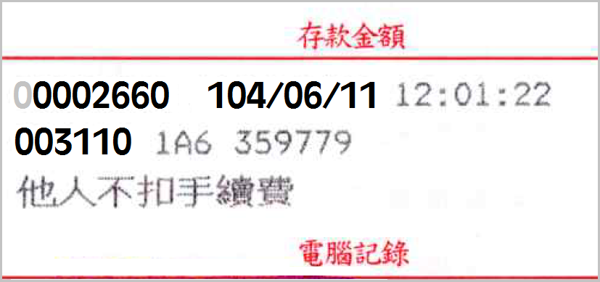  郵局局號Branch code  郵局收據編號 (8碼) Receipt No.(8 digits)  繳費日期Payment date
交易序號transaction No.
郵局局號Branch code

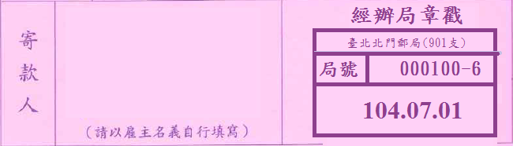
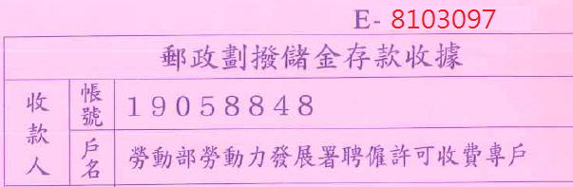
繳費日期Payment date
單位統一編號Entity Tax ID No. | 若係首次提出申請，請檢附統一編號編配證明影本。  For those employers that submit application for the first time, allocation notice of unified business number shall be attached
負責人  Owner | 請填寫單位負責人(代表人)之姓名。  Please enter the name of the owner.
行業類別代碼  Industry  Category Code | 請至「外國人在臺工作服務網」>「申請表件」>「行職業類別代碼」查詢。  Look it up at the website of EZ Work Taiwan > Application Forms > Code of Standard Industrial & Occupational Classification.
受聘僱外國人名冊 Employed Foreign Worker Name List
欄位 Field | 填寫方式及說明 Guidance
工作內容  Job Description | 請具體描述外國人所擔任職務之工作內容。  Please describe specifically the tasks or duties of the position.
具備外國特定專業人才資格 Foreign specialist personnel with special expertise | 請至「外國專業人才延攬及僱用法資訊專頁」查詢各部會公告資格。  To check the requirement announced by Ministrys, look it up at the website of “Act for the Recruitment and Employment of Foreign Professionals”  網址(website)：https://foreigntalentact.ndc.gov.tw
其他注意事項 Others
申請方式  Methods of application | 1.網路傳輸方式申請：應使用「外國專業人員工作許可申辦網」線上申辦方式辦理。  2.經勞動部同意採書面送件方式申請：  (1)由專人送至機關收件櫃台辦理。  (2)利用掛號郵寄申請，郵寄地址：100臺北市中正區中華路一段39號10樓，收件人註明：勞動力發展署（申請聘僱外國專業人員）收。  (3)相關申請書表可至「外國人在臺工作服務網」>「申請表件」下載，或至機關收件櫃台索取。  3.可親自辦理或委託私立就業服務機構辦理。  1. Application via internet: Please use the on-line application function in Work Permit Application Webpage for Foreign Professional, the address: https://ezwp.wda.gov.tw/.  2. Application via written correspondences:  i. Personally delivered Application to Reception Counter No. 6 for processing.  ii Mail application via registered mail.  iii. Related application forms can be downloaded from EZ Work Taiwan > Application Forms or obtained from the agency Reception Counter.  3. Application can be completed personally or entrusted to a private employment service agency.
申辦作業時間  Application processing time | 1.網路傳輸方式申請：若資料齊全，且雇主及外國人均符合所訂定的資格及條件，自本部系統收件次日起7個工作日。  2.書面送件方式申請：若資料齊全，且雇主及外國人均符合所訂定的資格及條件，自本部收受案件次日起12個工作日。  1. Application submitted online  7working days (counting from the next day when the application has been received), given that all the documents are complete and both the employer and employee have met the criteria.  2. Application submitted in person  12 working days (counting from the next day when the application has been received), given that all the documents are complete and both the employer and employee have met the criteria
審查費繳交  Examination  fee payment | (新聘及展延每案新臺幣500元；補發每案新臺幣100元)  1.利用郵政劃撥。劃撥戶名：勞動部勞動力發展署聘僱許可收費專戶，劃撥帳號：19058848  2.至機關收件櫃台現場繳交。  （New hire and Extension NT $500 per case；Re-issue NT $100 per case）  1. Via postal remittance, Account name: Work Permit Account of Workforce Development Agency, Account No.: 19058848).  2. Payment to the Reception Counter.
應備文件  Documents required | 1.請至「外國人在臺工作服務網」>「外國專業人才延攬及僱用法」查詢。  2.書面送件所附相關資料係為影本者，應加註「與正本相符」之文字，並加蓋申請單位及負責人印章。  1. Look it up at the website of EZ Work Taiwan > Foreign Professionals to Work in Taiwan.  2. If you apply for the use of written submittals, information and certification documents are copies, they should be marked with the words: “same as originals” and stamped with the seal of applicant entity and owner.
親自取件  In-person  Document Pickup | 1.如要親自取件，須填具「親自領件聲明書」並指派專人至機關收件櫃台送件申請。  2.於案件核准後，請憑收件(親取)回條並黏貼取件人身分證(護照或居留證)正、反面影本親自領取，倘於指定期限內未親自領取者機關將以掛號寄出。  1. If you wishes to pick-up documents in-person, “In-person Document Pick-up Declaration” must be filled-out, and you should submit application to the agency Reception Counter.  2. After application approval, a copy of ID (passport or ARC) and pick-up documents in-person with a receipt slip shall be attached. If documents have not been picked-up within the specified time limit, agency will mail out documents via registered mail.
申辦進度查詢  Application status | 請至「外國人在臺工作服務網」>「申請進度查詢」進行查詢。  You can check the status at the website of EZ Work Taiwan > Application Status.
機關網站與聯繫  Officail Websites & Contact | 1.勞動部勞動力發展署 Workforce Development Agency, MOL  https://www.wda.gov.tw  2.外國人在臺工作服務網 EZ Work Taiwan  https://ezworktaiwan.wda.gov.tw  3.外國專業人員工作許可申辦網 Work Permit Application Webpage for Foreign Professional  https://ezwp.wda.gov.tw  4.諮詢電話 Support Hotline：（02）89956000  5.機關收件櫃台：臺北市中正區中華路一段39號10樓  Reception Counter：No.39 Zhonghua Rd., Sec. 1, 10 Fl., Zhongzheng District, Taipei City

