僑外學生申請工作許可全面網路線上申辦問答集(Q&A)
Q & A of Work Permit Application Online for Foreign Students, Overseas Chinese Students, and Ethnic Chinese Students.
Q1:為什麼推行全面線上申辦？
Why implement the online application?
A1:基於線上申辦無紙化申請之數位趨勢，及線上申辦提供24小時線上送件、繳費、通知及查詢等服務，節省以往郵寄送件申請之時間及花費，亦不受限於政府機關上下班時間，享有免出門即可申辦的便捷，爰就僑外學生工作許可申請案件全面採行線上申辦。
Because the latest trend is online and paperless application and the fact that online applications offer 24-hour service for users to submit applications, pay the fees, receive notifications, and make inquiries. This not only saves time on delivery and relevant costs but also allows applicants to apply at their convenience! For this reason, the staff of the agency has implemented work permit applications online for foreign students, overseas Chinese students, and ethnic Chinese students.
Q2:全面線上申辦實施時間為何？
When is the online application implementation?
A2:自雇主聘僱外國人許可及管理辦法(已下簡稱雇聘辦法)第6條之1條文修正施行日起，全面採行線上申辦。
It was effective on the day Article 6-1of Regulations on the Permission and Administration of the Employment of Foreign Workers was amended.

Q3:我還能用書面方式申請嗎？
Can I submit a paper application?
A3:如果有正當事由(如因發生天災、事變等不可抗力因素，或如本部線上申辦系統無法提供服務等其他不可歸責事由)，學生可以書面送件申請，並檢附說明書，由本部個案認定。
If having suitable cause (for example natural disasters, events of force majeure, or other circumstance not attributable by the agency such as the online application system can’t provide relevant services), students may submit the paper application with a note stating the reasons. Our staff will decide whether to accept it or not.

Q4:紙本送件申請被退請改採線上申請，審查費需重新繳納嗎？
If an application is submitted online after a paper application was returned, does the applicant need to pay the review fee again?
A4:由於紙本送件申請案並未進行實質審查，本部將不收取前揭申請案件之審查費，故該筆審查費仍可於其他申請案使用。
Since the paper application was not reviewed, the agency will not charge a fee for it. The review fee may be used for another application.

Q5:線上申辦系統網址為何？
What is the website address of the online application system?
A5:外國專業人員工作許可申辦網網址為https://ezwp.wda.gov.tw/，請點選「僑外生工讀申請」，申請帳號後即可進行案件申請。
The website of the work permit application for foreign professionals is https://ezwp.wda.gov.tw/, click “Work Permit Application for Foreign Students, Overseas Chinese Students, and Ethnic Chinese Students.” Create an account before applying for a work permit online.
Q6:有無線上申辦操作手冊？
Is there a user manual for the work permit online application?
A6:本部「外國專業人員工作許可申辦網」首頁備有中英文版操作手冊及教學影片等連結，歡迎多加利用。
The front page of “EZ Work Permit” offers operational manuals and links to instructional video clips in both Chinese and English versions. You are welcome to use them.

Q7:線上申辦操作時如有相關問題，是否有其他管道可供諮詢？
Are there any channels for assistance if the applicant has any relevant questions while applying online?
A7:可e-mail至線上系統客服電子信箱：ezwp@wda.gov.tw，或於上班時間(上班日上午8：30~12：30，下午13：30~17：30)撥打線上系統客服專線：0800-881-339或(02)2380-1720，將有專人協助指導及處理相關問題。
Please send an email to our customer service at ezwp@wda.gov.tw or call our online system service hotline at 0800-881-339 or (02)2380-1720 during business hours (8:30-12:30 & 13:30-17:30 on workdays).

Q8:線上申辦系統是否有資訊安全風險？
Are there info security risks using the online application system?
A8:為確保資訊安全與資料來源之可靠性，學生申請註冊帳號後，請妥為保存帳號及密碼。又案件經本部收件、審核無誤後核發許可，申請及審查訊息將同步以電子郵件通知，於註冊帳號時，請確實填寫個人電子信箱，避免偽冒申請。
To ensure the safety and reliability of the info, after registering to create an account, students need to keep their account names and passwords properly secure. Work permits will be issued after the application is accepted and reviewed by the agency. Relevant info regarding applications and reviewing will be sent to the applicant by email. To avoid applications by someone other than the registered user of the account, please enter the correct email address.

Q9:線上申辦之建檔作業為何？
How to set up and file an application via the online application system?
A9:學生以帳號登入線上申辦系統，依網頁所設欄位點選或登打必要資訊，並上傳相關資料(檔案應為PDF檔)，即可送件申請。
Students need to log in with the account name they created; enter the required info in the columns, then upload the required documents (in PDF files) to apply.

Q10:線上申辦之申請案如經本部退請補正，能否即時補件處理？
If an application submitted via the system is returned for corrections, can the applicant make the corrections immediately?
A10:線上申辦之案件如因資料缺漏等原因經本部退請補正，除將正式發函通知外，亦將以e-mail通知，學生可於接獲通知後，旋即於系統進行補正作業，並請以該補正案件進行補正，不用另開新案，以免造成重複送件之情形。
If an application submitted via the system is returned for corrections for reasons such as info missing, in addition to issuing a formal notification to the applicant, the Ministry will also notify the applicant through email. Students may make the relevant corrections on the system as soon as they receive it. There is no need to create a new application to avoid double submission.
Q11:僑外學生申請工作許可期間如何核給？
For how long could the validity periods of work permits for foreign
students, overseas Chinese students and ethnic Chinese students be?
A11:學生申請工作許可期間，依本部公告之審查作業手冊所載，於上學期提出者，工作許可之期限原則至次學期之3月31日止，於下學期申請者，工作許可之期限原則至同年之9月30日止，惟申請之許可期間較短者，將依其申請期限核予許可，考量學生之工讀需求不一，仍依其申請期限為準。惟最長仍以6個月為限。
Please refer to the review manual publicly announced by the agency for the validity periods of students’ work permits. For those who apply in the 1st semester, the work permits are valid until March 31 of the 2nd semester. For those applying in the 2nd semester, their work permits will be valid until September 30 of the same year. Permits with shorter validity periods may be issued, based on the period when students apply. Because requirements for each student’s part-time job are different, validity periods of the work permits are based on the applications, but the longest period is 6 months.

Q12:工作許可證的寄送地址可否依據學生寫的地址寄送？
Will the issued work permit be sent to the address provided by the
student when applying?
A12:為避免學生因地址誤繕或模糊難辨致誤寄，影響學生工作權益，且為利學校得以瞭解本部工作許可核發情形，爰統一郵寄學校單位協助處理，以降低學生反應未收到工作證之情形。
To avoid work permits being sent to the wrong addresses provided by students or getting too blurred to read, which might affect their work rights, and for the school staff to monitor the updates of work permits issued by the agency, all students’ work permits will be sent directly to their schools.

Q13:護照換發應如何辦理護照號碼更新？
How does an applicant revise his/her passport number after a
passport renewal?
A13:請於提出工作許可申請時，併同檢附新、舊護照供審核，本部將據以協助辦理變更。
One may apply for such revision while applying for the work permit. Please attach both new and old passports for review. The Ministry will help the applicants renew the passport numbers on their work permit.
Q14:審查費應如何繳納？
How to pay for the review fees?
A14:可利用郵政劃撥後至系統填寫收據資料(劃撥戶名：勞動部勞動力發展署聘僱許可收費專戶，劃撥帳號：19058848) 或使用ATM繳費，以ATM繳費請於取得繳費序號後儘速繳納。
Applicants need to fill in the receipt information online after postal remittance (Account name: Work Permit Account of Workforce Development Agency, Account No.: 19058848) or pay via ATM: please proceed with the payment as soon as possible once you have the payment serial no.

Q15:郵政劃撥繳交審查費，收據資料應如何填寫？
How to fill in the receipt info after postal remittance?
A15:審查費收據應填資料如下，請務必填寫正確：(1)交易日期：即繳費日期，例如107年9月26日繳費，線上申辦請填入1070926。 (2)交易局號 ：即該繳費郵局之局號，相關範例如下圖所示。 (3) 收據編號：請勿填寫本署劃撥帳號19058848，相關範例如下圖所示。請於案件申請時參考注意事項及範例說明。
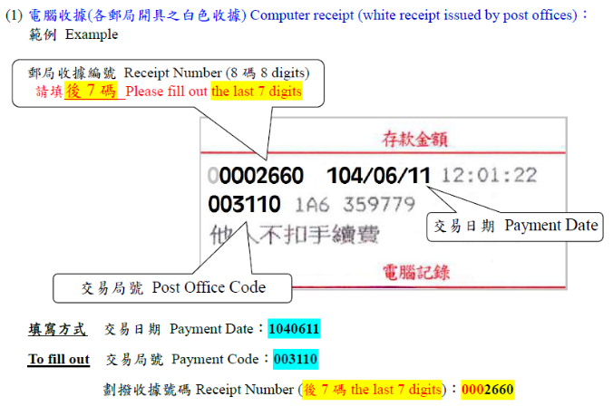
Information to be filled in the receipt info is as follows. Please make sure the info provided is correct: (1) Payment date: the date the fee was paid. For example, please enter 1070926 if you paid the fee on September 26, 2018. (2) Branch code: the branch code of the post office where you remitted the fee. A relevant example is shown in the diagram below. (3) Receipt no.: please don't enter our remittance account no. 19058848. A relevant example is shown in the diagram below. Please refer to notices and examples when applying for work permits.
或

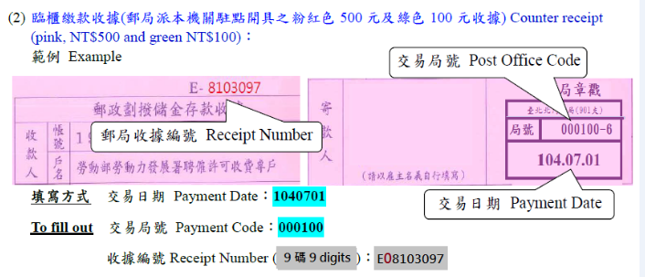
Q16:大學畢業後，確定會就讀同校碩士班，在下一學期尚未註冊前，若欲利用暑假期間實習或留在研究室做研究，其工作許可如何申請？
How do new graduates apply for their work permits if they will go to the graduate school of the same university but the enrollment of the new semester is not yet begun and they would like to have a summer internship or do research in the research room on campus?
A16:依所公告僑外學生申請工作許可審查作業手冊規定，高中及大學應屆畢業生（含延畢生）工作許可期限至同年6月30日止。學生若有暑修或延畢之需要，由學校或(系)所出具相關證明，或考取大學或研究所，加附由錄取學校出具該生已完成報到手續之證明文件即可申請延長許可期限至同年9月30日。
According to the regulations in the review manual of work permit application for foreign students, Overseas Chinese students and ethnic Chinese students announced by the Ministry of Labor, work permits for senior high school students and new university/college graduates (including students whose graduation is delayed) are valid till June 30 of the same year. Students who will go to the summer classes or delay their graduation must present the relevant proof document issued by the school or their department. Students already admitted to a university (college) or graduate school should attach a document stating that he/she has completed the registration procedure issued by the school so that they may apply to extend the valid period of their work permit to September 30 of the same year.

