僑外學生申請工作許可以電子公文方式送達工作許可函
問答集(Q&A)-學生版
Q & A for Electronic Service of Student Work Permit.

Q1:為什麼推行電子送達？
Why implement the electronic service?
A1:基於線上申辦無紙化申請之數位趨勢，並配合「雇主聘僱外國人許可及管理辦法」第6條之1修正規定，自108年2月1日起僑外學生申請工作許可已採全面線上申辦。為擴大運用網際網路之效益，達成簡政便民之目的，本部參採相關機關電子送達之作法，於「外國專業人員工作許可申辦網」，依電子簽章法之規定與僑外學生約定並取得「同意」後，就僑外學生工作許可申請案件經本部核准後，即以電子公文方式送達工作許可函。
For the latest trend is online and paperless application and due to the amendment of article 6-1 of Regulations on the Permission and Administration of the Employment of Foreign Workers, online application for student work permit has been implemented since 1 February 2019. To take advantage of the internet and facilitate the application process, after consulting other government agencies, now on the EZ Work Permit website, if the applicant agrees, according to Electronic Signatures Act, the work permit issued will be sent as electronic documents.

Q2:電子送達實施時間為何？
When is the electronic service implementation?
A2:自109年1月1日起實施。僑外學生於「外國專業人員工作許可申辦網」經約定「同意」以電子公文方式送達工作許可函，於申請案件經本部核准後，即可逕至本部「外國專業人員工作許可申辦網」領取電子公文。
It takes effect on 1 January 2020. When foreign students who apply for work permit on EZ Work Permit website agree on the electronic service. After the work permit has been issued, the applicant can then collect the electronic document (work permit) on the website.

Q3:如何申請同意電子送達？
How to apply for electronic service?
A3:首先登入本部「外國專業人員工作許可申辦網」，於「案件新增及管理」項下點選「新增申請案件」後，將彈跳出約定是否同意電子送達視窗，請於詳讀約定內容後按下「同意」按鍵即完成約定，屆時本部將以電子公文方式送達工作許可函。如點選「不同意」，則工作許可申請案件經本部核准後，將以郵寄方式寄發紙本工作許可函。
Log into the “EZ Work Permit” website, click “New Application and Management” > “Add Application”, and a pop-up window will show the agreement of electronic service. Press "Yes" if you agree, and the work permit issued will be sent as electronic official document. If you click "No", the work permit (paper) will then be delivered by post.

Q4:申請補發工作許可也可以約定電子送達嗎？
Does electronic service apply to applications of reissuance of work permit?
A4:電子送達以許可函為限，除新申請之工作許可，也包含因原工作許可遺失等因素申請補發許可者，均得以約定以電子公文方式送達工作許可函。
Electronic service only applies to work permit issued, which includes new application and reissuance (due to loss of the original one).

Q5:同意電子送達後能反悔嗎？
Can I retract my agreement on electronic service?
A5:(1)原則上，申請案件如已送本部審查，則無法變更工作許可函領取方式。
(2)若於申請案件送本部審查前，原約定同意電子送達因故擬予變更工作許可函領取方式，仍可於案件管理頁面之「工作許可函公文領取方式」操作變更，點選「郵寄學校」者，於案件經本部核准後，將以郵寄方式寄發紙本工作許可函；點選「親自領取」者，則請於案件經本部核准後逕自本部領件櫃檯(臺北市中正區中華路一段39號10樓)取件。
(1) Once the application has been filed, receiving method of the work permit cannot be changed.
(2) If you intend to change the receiving method before submitting the application, you can revise in “Case Management”. If you select “deliver to the school”, the work permit issued will be sent to the school by post；If you select “Pick up in Person”, please come to our office to collect the permit after it is issued. (10F, No. 39, Sec. 1, Zhonghua Rd., Zhongzheng Dist., Taipei City)

Q6:什麼時候可以領取電子公文？會通知嗎？
When can I collect the electronic official document? Will I receive a notification?
A6:本部將於申請案件核准且發文後，以電子郵件通知僑外學生領取電子公文，僑外學生並可於發文日起8個日曆天內自行至本部「外國專業人員工作許可申辦網」領取電子公文；逾期未領件者，系統將關閉「領取電子公文」功能。
Once your work permit has been approved and issued, you will be contacted by email. You can collect the electronic official document on EZ Work Permit website within 8 days. This function will be locked after 8 days from the date of issue.

Q7:逾期領取電子公文怎麼辦？
What if I have missed the pickup deadline?
A7:如未能於發文日起8個日曆天內至本部「外國專業人員工作許可申辦網」領取電子公文，屆期本部將逕改以紙本公文寄發工作許可函。
If you cannot collect the electronic documents within eight days, the Ministry will take down the electronic documents and deliver the official documents in hard copy by registered mail.

Q8:領取電子公文時因電腦當機、印表機故障等情況致領取失敗怎麼辦？
What can I do if I fail to collect the electronic official document because my computer crashed or my printer did not work?
A8:如因不可歸責事由無法成功領取電子公文，仍可於發文日起8個日曆天內申請重新領取，請於案件管理頁面點選「重新申請領取電子公文」，填寫事由並按下「確認」後，系統將寄發驗證密碼至註冊信箱，請前往收件並將取得之驗證密碼鍵入系統完成身分驗證後，本部將再次開放領取電子公文，並以僑外學生成功領取電子公文之時間為電子公文送達時間。如逾前述期限則無法申請重新領取，請依補發程序另案申請補發許可。
If the electronic official document cannot be collected due to reasons which are unable to blame on the applicant, within 8 days from the date of issue the applicant can reapply for collecting. In “Case Management”, click “Reapply for collecting the electronic official document”, enter the reason and confirm, and then the system will send a verification code to the registered email. After verification, the applicant can collect the electronic official document. The time of the electronic service shall be deemed as the time recorded by system when you have collected the electronic official document successfully. After 8 days from the date of issue, please submit an application for reissuance of the work permit.
Q9:我可以透過手機出示工作許可相關資訊嗎？
Can I display the details of my work permit on mobile?
A9:如「同意」以電子公文方式送達工作許可函者，本部新增使用「行動裝置檢視工作許可」功能。即僑外學生工作許可申請案件經本部核准後，學生以行動裝置登入「外國專業人員工作許可申辦網」，點選「行動裝置檢視」，系統將寄送驗證碼至案件申請時所填之手機號碼，並於輸入驗證碼後，啟用行動裝置檢視功能，當行動裝置直立時，顯示畫面為QRcode(如下圖1所示)，可供雇主掃描驗證；當行動裝置橫放時，顯示畫面為工作許可相關資料(如下圖2所示)。
You can view your work permit on your mobile devices if you agree on electronic service. After the application is approved, you can log into the “EZ Work Permit” website on your mobile devices and view the work permit on them. The system will send the verification code to the mobile number you entered, after verifying you can then view your work permit on your mobile devices. When the screen displays in portrait (vertical), a QR code will be generated (as shown in picture 1). The employer can scan the QR code to check details. When you rotate the screen to landscape (horizontal), the information of the work permit will display (as shown in picture 2).
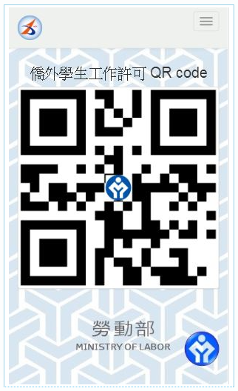
picture 1

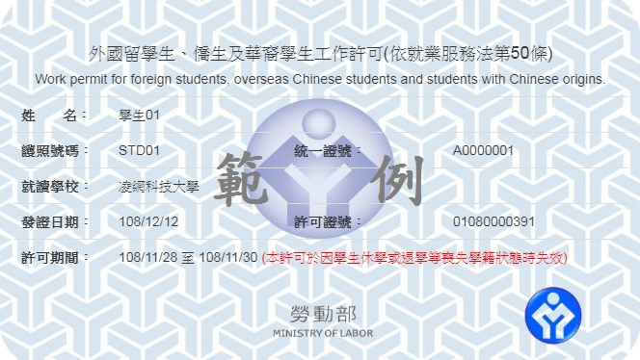
picture 2
Q10:我要如何申請「行動裝置檢視工作許可」功能？
How to view my work permit on mobile devices?
A10:如「同意」以電子公文方式送達工作許可函者，於案件管理頁面「工作許可函行動裝置檢視」欄位，本部將此功能預設為「是」，則請務必輸入您的手機號碼以作為寄送驗證碼之用，如不願使用此功能，則請將此欄位改點選為「否」。
If you agree on the electronic service, the default setting for viewing your work permit on mobile devices is “YES”. Be sure to enter your mobile number so as to receive the verification code. If you do not want to view your work permit on your mobile devices, please click “NO”.
Q11:線上申辦操作時如有相關問題，是否有其他管道可供諮詢？
If I have any questions regarding online application, who can I contact for additional guidance?
A11:可e-mail至線上系統客服電子信箱：ezwp@wda.gov.tw，或於上班時間(上班日上午8：30~12：30，下午13：30~17：30)撥打線上系統客服專線：0800-881-339或(02)2380-1720，將有專人協助指導及處理相關問題。
You can contact us by email (ezwp@wda.gov.tw) or call the service center (0800-881-339 or 02-23801720) during office hours on working days (8：30~12：30, 13：30~17：30), and someone will assist you with your inquiries.
Q12:雇主該如何掌握僑外學生工作許可情形？
How can an employer check the status of student work permit?
A12:本部「全國外籍勞工動態查詢系統」，提供雇主即時線上查詢功能。雇主於登入系統後，鍵入僑外學生工作許可函發文文號及護照號碼並點選「查詢」，即可瞭解僑外學生工作許可情形。
Employers can log into the Foreign Labor Searching System, enter the work permit file number and the passport number of the foreign student to check the status of the work student work permit.

Q13:我還收得到紙本工作許可證嗎？
Will I still receive a work permit on paper?
A13:現行核發之「外國留學生、僑生及華裔學生工作許可證」，為配合以電子送達方式核發工作許可之推行，自109年1月1日起工作許可申請案件經本部核可後，將不再寄發紙本「工作許可證」，改以核發工作許可函之形式(如下圖所示)作成處分。
As electronic services implementation from 1 January 2020, for the application approved, the Ministry of Labor no longer issues student work permit card. An official document (as shown in the picture below) would be issued instead.

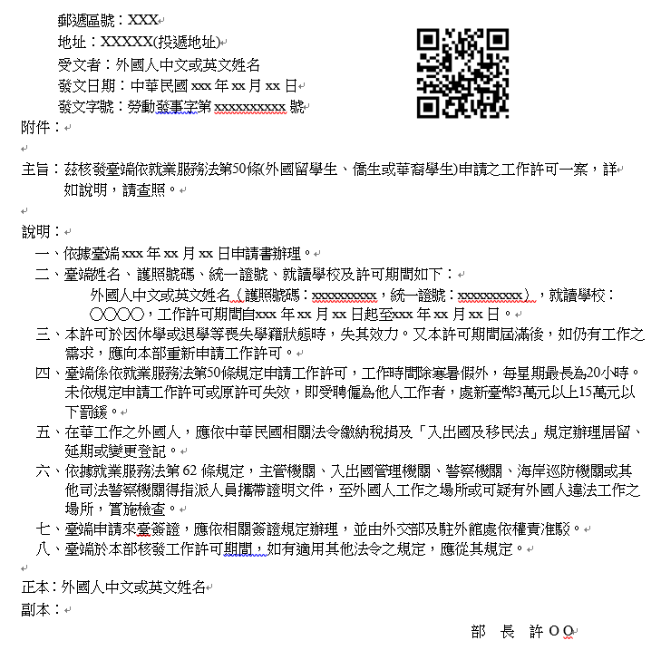

Q14:電子公文(如下圖所示)、紙本公文及行動裝置檢視功能畫面所顯示的QRcode功能為何？
What is the QRcode on the work permit for?
A14:雇主可藉由掃描QR code即時顯示僑外學生許可期間，方便其瞭解僑外學生工作許可情形。
The employers can scan the QR code to check the period of validity of the foreign student work permit.
